The Islamia University of Bahawalpur Department of Information Technology



Software Design Description

(SDD Document)

For

<Diet and Fitness Advisor>

By

Ayman Afzal

F22NINFT1M01042

Session Fall 2022-2026

Supervisor

Mr. Muzammil U Rehman

Introduction
An AI Based Personal Diet and Fitness Advisor is a software system designed to provide personalized diet plans and fitness recommendations using Artificial Intelligence. The system analyzes user data such as age, gender, weight, height, lifestyle, health goals, and dietary preferences to generate customized guidance.
The purpose of this system is to help users maintain a healthy lifestyle, achieve fitness goals, and improve overall well-being through intelligent, data-driven recommendations.

Design Methodology and Software Process Model
The system follows the Object-Oriented Programming (OOP) methodology.

Design Methodology

Justification:
- OOP allows modular, reusable, and scalable system design.
- Entities like User, Diet Plan, Workout Plan, and Progress Tracking can be modeled as objects.
- Improves maintainability and future enhancements.

Software Process Model
The Agile Software Development Model is used.

Justification:
- Supports iterative development and continuous improvement.
- Allows regular updates to AI models and recommendations.
- User feedback can be incorporated easily.

System Overview
The AI Based Personal Diet and Fitness Advisor is a web/mobile-based application that provides personalized health recommendations. Users can register, input their health data, set fitness goals, and receive diet and workout plans.
The system continuously monitors user progress and updates recommendations using AI algorithms.

Key Features:
- User registration and profile management
- Personalized diet plans
- Customized workout routines
- Progress tracking
- AI-based recommendations
- Notifications and reminders

Architectural Design
The system follows a Multi-Tier Architecture:

Presentation Layer

User interface (Web or Mobile App)

Displays diet plans, workouts, and progress

Collects user input

Business Logic Layer

Processes user data

Applies AI algorithms

Generates recommendations

Data Layer

Stores user profiles, diet plans, workout data, and progress

Maintains historical records

System Decomposition (Modules)

User Management Module

Handles user registration and login

Manages user profiles and preferences

Diet Recommendation Module

Generates personalized diet plans

Calculates daily calorie requirements

Suggests healthy food alternatives

Fitness Recommendation Module

Provides customized workout plans

Adjusts workouts based on fitness level

Progress Tracking Module

Tracks weight, calories, and workout completion

Shows progress reports and charts

AI Recommendation Engine

Analyzes user data and behavior

Updates diet and workout plans automatically

Notification Module
- Sends reminders for meals and workouts
- Motivational alerts and tips

FlowChart
Start
↓
User Registration / Login
↓
Is User Registered?
┌───────────────┐
│ No │
│ Register User │
└───────────────┘
↓
Yes
↓
Enter Personal Information
(Age, Gender, Height, Weight)
↓
Enter Lifestyle & Preferences
(Activity Level, Food Preference)
↓
Select Fitness Goal
(Weight Loss / Muscle Gain / Healthy Life)
↓
AI Engine Processes User Data
↓
Calculate BMI & Daily Calories
↓
Generate Personalized Diet Plan
↓
Generate Personalized Workout Plan
↓
Display Diet & Fitness Plan to User
↓
User Follows Plan
↓
Track Progress
(Weight, Calories, Workout)
↓
Is Goal Achieved?
┌───────────────┐
│ No │
│ Update AI Plan│
└───────────────┘
↓
Yes
↓
Show Success & Maintenance Plan
↓
End

Design Models

Class Diagram (Description)

Main Classes:

User

DietPlan

WorkoutPlan

Progress

RecommendationEngine

Notification

Relationships:

A User can have multiple DietPlans and WorkoutPlans

A User has one Progress record

RecommendationEngine generates DietPlan and WorkoutPlan

Sequence Diagram (Description)

User logs into the system

User enters health data and goals

System sends data to AI Engine

AI Engine analyzes data

Diet and workout plans are generated

Recommendations are displayed to the user

State Transition Diagram (User Progress)

New User

Active User

Following Plan

Progress Improved

Goal Achieved

Data Design

Major Data Entities:

User

DietPlan

WorkoutPlan

Progress

Notification

Data Storage:

User Database

Diet & Workout Database

Progress Tracking Database

Data Dictionary (Summary)

User

UserID

Name

Age

Gender

Height

Weight

FitnessGoal

DietPlan

PlanID

Calories

MealDetails

WorkoutPlan

WorkoutID

ExerciseList

Duration

Intensity

Progress

ProgressID

Date

Weight

CaloriesBurned

Algorithm & Implementation (High-Level)

Diet Recommendation Algorithm:

Take user input (age, weight, goal)

Calculate BMI and calorie needs

Generate meal plan using AI rules

Display diet plan

Fitness Recommendation Algorithm:

Analyze user fitness level

Select suitable exercises

Create workout schedule

Update based on progress

Process Flow/Representation
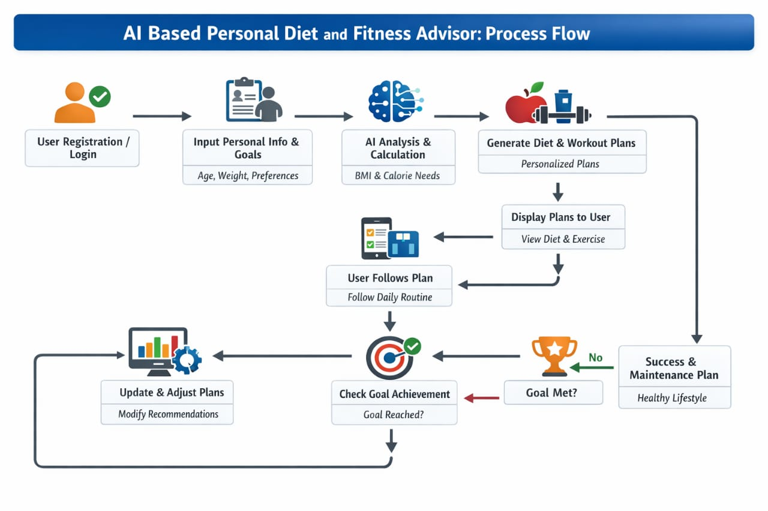
This diagram represents the overall process flow of the AI Based Personal Diet and Fitness Advisor, showing how user data is analyzed by the AI system to generate personalized diet and workout plans and continuously update them based on progress.

Software Requirements Traceability Matrix

Requirement Description Module

FR01 User Registration User Management

FR02 Diet Plan Generation Diet Module

FR03 Workout Recommendation Fitness Module

FR04 Progress Tracking Progress Module

FR05 Notifications Notification Module

Human Interface Design

The system provides a user-friendly interface with:

Simple navigation

Clear dashboards

Visual progress charts

Easy data input forms

Responsive design for mobile and web

Conclusion

The AI Based Personal Diet and Fitness Advisor is an intelligent system that helps users adopt a healthy lifestyle through personalized recommendations. By using Artificial Intelligence and data analysis, the system provides accurate, adaptive, and effective diet and fitness guidance.

